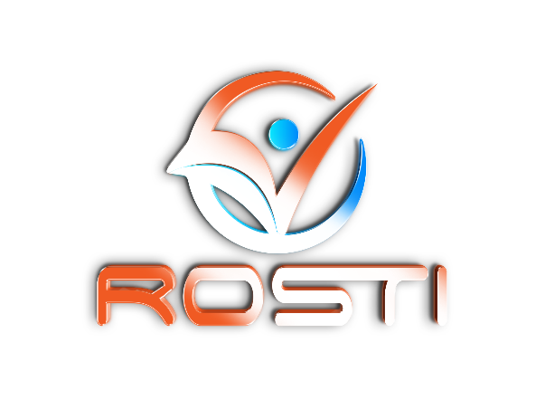

Register of Orthopaedic and Soft Tissue
Therapists of Ireland

RENEWAL OF MEMBERSHIP

Please note that it is in your best interest to fully complete this form, providing a contact phone number, email address and website where relevant. Please write clearly. This will allow ROSTI to advertise its therapists to the very best of our ability.

As of January 2019, only members who have completed or signed up for the Higher Diploma in Orthopaedic and Soft Tissue Therapy will be accepted for renewal. For more information on this please refer to Saint Martin`s College Co. Cork.

Please fill in this application form and return it with to ROSTI at the following address.
Shane Mooney
C/O Sheehan Physiotherapy, Exchange House,
Main St. Ballincollig, Cork.

Membership fee may be paid by cheque (made out to ROSTI) or bank transfer using the following bank details;

Bank of Ireland Ballincollig
Branch Number: 90 26 45
Account Number: 54500414
IBAN: IE30 BOFI 9026 4554 5004 14
BIC: BOFIIE2D

Please add your name to the transfer as a reference.

Personal information
Please use block capitals throughout this application form.

Surname: _____________________________________ Mr / Mrs / Miss / Ms

Forename(s): _______________________________ Nationality: ______________

Name in which your qualification was awarded, if different from your present name:
__________________________________________________
*Please enclose evidence of name change. A copy of your marriage certificate/deed poll etc.

Address: __________________________________________

__________________________________________

__________________________________________

Sex: M / F Date of Birth: ____________________________

Telephone: __________________________ Mobile: _____________________________

Email: ______________________________ Website: ____________________________

Membership

Membership to ROSTI is available to fully qualified Orthopaedic and Soft Tissue Therapists only. It provides the therapist with a support network of therapists from all over Ireland. Members may avail of competitive insurance rates through ROSTI’s group insurance scheme. Members will be offered CPD courses at reduced rates. Members are approved by VHI, Layal, Aviva Healthcare and other Irish Insurers.

Please tick the boxes below to verify compliance with membership requirements.

I wish to renew my Full Membership of R.O.S.T.I (€90 annually).
I have complied with all CPD requirements.
I have a valid and up to date occupational First aid certificate.
I have completed or signed up for the Higher Diploma in Orthopaedic Therapy at Saint Martin`s College.
I have joined the ROSTI group insurance scheme through Sheridan Insurance Cavan.
Membership will not be granted to therapists who have not complied with all the membership requirements listed above.

The Register of Orthopaedic and Soft Tissue Therapists of Ireland reserves the right to randomly audit any of its members to ensure they are complying with their first aid, insurance and CPD requirements.

I hereby declare that the information I have provided above is correct to the best of my knowledge.

Signed: ____________________________________ Date: _________________

